Advanced Molecular Imaging Facility
Michigan State University

Facility Overview
The Advanced Molecular Imaging Facility (AMIF) is a shared research resource that supports the small-animal imaging needs of Michigan State University investigators and external academic and commercial users. The facility occupies approximately 2,000 square feet on the first floor of the Institute for Quantitative Health Science and Engineering on the south end of the Michigan State University campus. AMIF provides integrated MRI, PET, magnetic particle imaging, optical imaging, microCT, and optoacoustic imaging capabilities for longitudinal studies in preclinical models.
Facility personnel assist investigators with study design, imaging protocol development, image acquisition, and quantitative analysis. Users may be trained to operate individual systems or may request fee-for-service imaging and analysis. Dedicated workstations support image reconstruction, registration, visualization, kinetic modeling, and quantitative analysis. Imaging systems are equipped with isoflurane delivery and animal positioning equipment appropriate to each modality. The facility also includes a downdraft table for necropsy and other procedures involving formalin.

Scientific and Technical Leadership
Erik Shapiro, PhD, serves as Faculty Director. He has more than 20 years of experience in preclinical imaging, with expertise in the development and application of MRI and PET/MRI methods for measuring disease progression and treatment response in preclinical models. He also has extensive experience using microCT to image radiopaque biomaterials and provides guidance in experimental design, image acquisition, quantitative analysis, and user training.
Jeremy Hix, BS, LATG, SRT, serves as Facility Manager. He has more than 10 years of experience in preclinical research using imaging and telemetry. He is certified as a Laboratory Animal Technologist by the American Association for Laboratory Animal Science and as a Surgical Research Technician by the Academy of Surgical Research. His technical expertise includes animal preparation, imaging workflows, and surgical procedures, with particular experience in vascular surgery.

Preclinical PET MRI
AMIF operates a Bruker BioSpec 70/30 7 T MRI system with a removable PET insert. The PET detector can operate as a stand-alone system or within the MRI bore for simultaneous PET and MRI acquisition. Radiofrequency coils support proton imaging of the mouse brain and body, rat brain and body, and animals up to rabbit size. Available MRI methods include high-resolution anatomical imaging, functional MRI, diffusion-weighted imaging, chemical exchange saturation transfer, and spectroscopy. The PET insert supports dynamic imaging with temporal resolution as short as 5 seconds and spatial resolution of approximately 0.7 mm for fluorodeoxyglucose imaging.
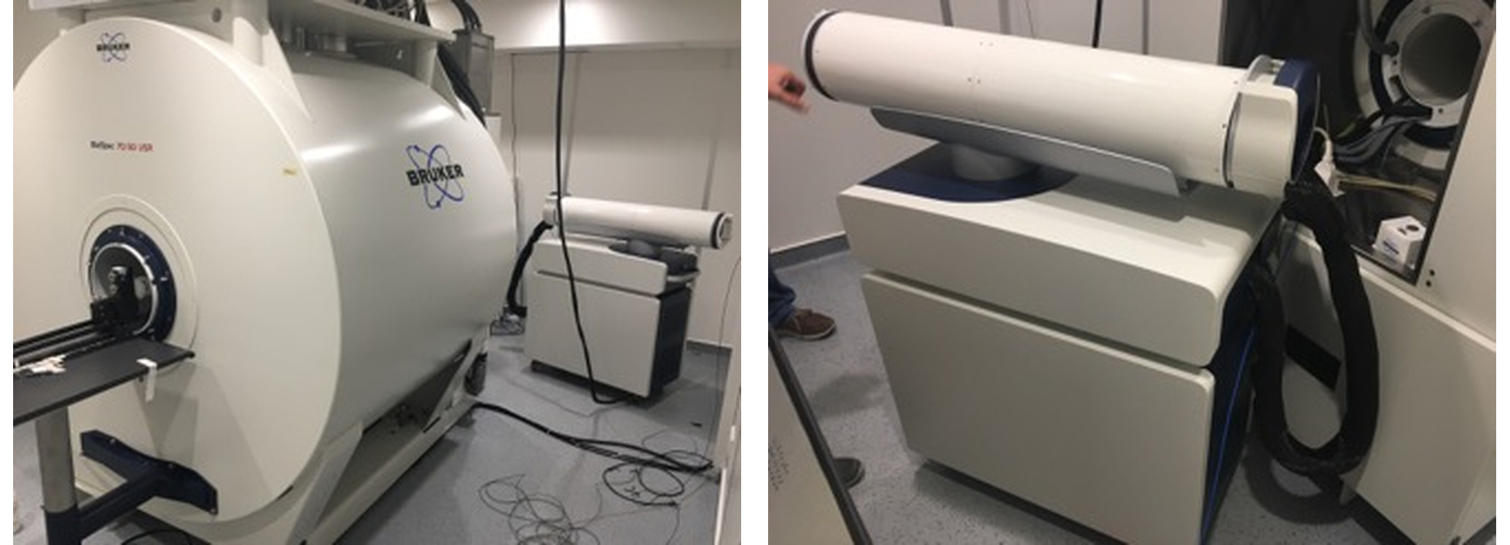
Bruker BioSpec 7 T MRI system and removable PET insert.
The PET imaging area includes lead shielding, a dose calibrator, survey meters, and equipment for radiotracer administration. Fluorodeoxyglucose is obtained from Cardinal Health, located adjacent to the facility. Other radionuclides, including copper-64, yttrium-86, and zirconium-89, can be obtained from external production facilities as required. Nearby radiopharmacy resources support development and production of imaging agents in research and cGMP environments.
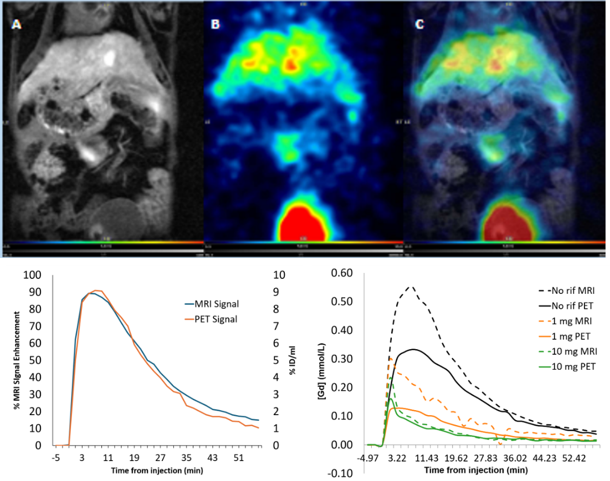
Representative simultaneous PET MRI images and kinetic analysis.

Additional MRI Resources
AMIF also has access to a second Bruker BioSpec 7 T MRI system with a 31 cm bore and a Bruker 9.4 T system with a 9 cm vertical bore in the Biomedical and Physical Sciences Building. These systems support high-resolution anatomical MRI, functional MRI, and multinuclear magnetic resonance spectroscopy, including fluorine-19 and phosphorus-31. Commercial and custom-built radiofrequency coils are available for a range of animal sizes, anatomical targets, and nuclei.

Magnetic Particle Imaging
A Magnetic Insight MOMENTUM scanner provides magnetic particle imaging of superparamagnetic iron oxide tracers. The system produces quantitative positive-contrast images based on the magnetic response of the particles and includes a relaxometry module for tracer characterization. The mouse bed contains fiducial markers that facilitate registration of three-dimensional magnetic particle images with microCT. VivoQuant is available for image visualization and analysis.
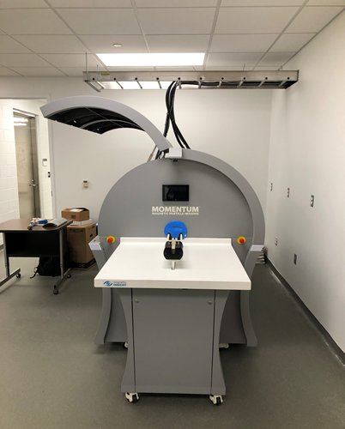
Magnetic Insight MOMENTUM magnetic particle imaging system.

Fluorescence and Bioluminescence Imaging
A PerkinElmer IVIS Spectrum supports in vivo bioluminescence and fluorescence imaging, including high-throughput planar imaging and three-dimensional optical tomography. The light-tight imaging chamber includes a heated stage and integrated isoflurane anesthesia for longitudinal imaging. Excitation and emission filter sets support imaging from blue through near-infrared wavelengths, spectral scanning, spectral unmixing, and visualization of multiple fluorescent or bioluminescent reporters in the same animal. Diffuse optical tomography can be used to estimate source location and signal concentration and can be registered with a digital mouse atlas, microCT, or MRI. Living Image software is available for analysis.
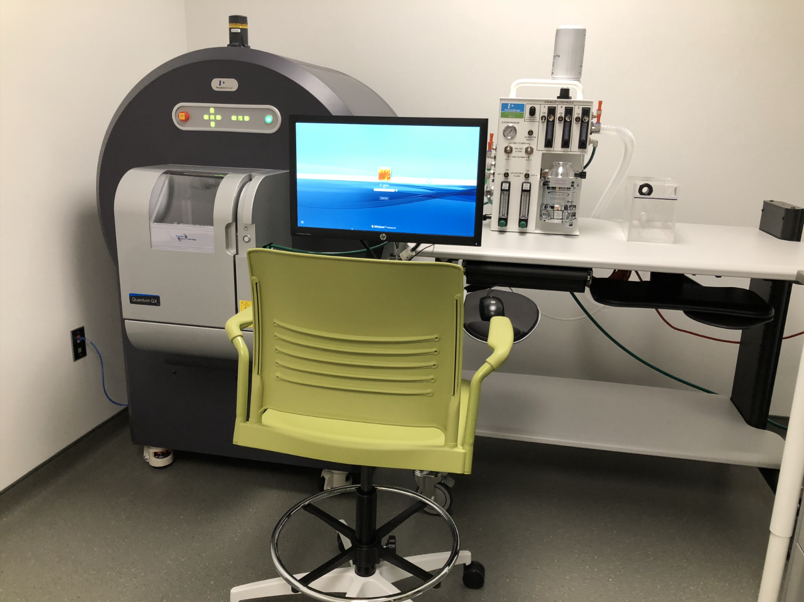
PerkinElmer IVIS Spectrum optical imaging system.

MicroCT
A PerkinElmer Quantum GX microCT system supports anatomical and materials imaging with cardiac and respiratory gating, an adjustable tube-voltage range of 20 to 90 kV, and fields of view suitable for mice, rats, and rabbits. The system provides high-resolution, high-speed, and standard acquisition modes. Voxel sizes of 4.5 micrometers at a 36 by 36 mm field of view and 9 micrometers at a 72 by 72 mm field of view are available for high-resolution imaging. High-speed acquisitions can be completed in approximately 8 seconds, with reconstruction in approximately 15 seconds. Subreconstruction tools allow selected regions to be reconstructed at higher resolution without rescanning the animal.
Two bone-mineral-density calibration phantoms are available for quantitative studies. Analyze 14.0 supports image analysis, and additional modules provide morphometric assessment of cortical and trabecular bone using established bone-analysis measures.

Optoacoustic Imaging
An iThera MSOT inVision 512-echo system provides hybrid multispectral optoacoustic and ultrasound imaging in mice and rats. Pulsed laser illumination produces thermoelastic expansion, and the resulting ultrasound waves are detected by a 270-degree array of 512 ultrasound detectors operating at 5 MHz. The system generates registered tomographic ultrasound and optoacoustic images at approximately 150 micrometers resolution and moves the animal through the detector ring for whole-body coverage. Endogenous contrast can distinguish oxyhemoglobin and deoxyhemoglobin, while exogenous contrast agents can include indocyanine green, methylene blue, or nanoparticles. A handheld detector is available for larger subjects, and iThera software supports image reconstruction and analysis.

Image Analysis and Data Support
Analysis workstations are equipped with ParaVision 360 and PMOD, including image-fusion and kinetic-modeling tools. Additional PMOD modules can be added for specialized applications such as cardiology or neurology. Modality-specific software includes Living Image for optical imaging, Analyze 14.0 for microCT, VivoQuant for magnetic particle imaging, and iThera software for optoacoustic imaging. Facility staff can train investigators in these tools or provide analysis as a fee-for-service activity.

Animal Housing and Procedural Support
Mice and rats used in imaging studies can be housed in dedicated holding rooms within the facility. Campus Animal Resources maintains these rooms under Michigan State University’s animal-care program. The animal facilities are accredited by AAALAC International, and the institutional program is registered with the U.S. Department of Agriculture. Animals are housed in sterile cages, and the holding area includes biosafety cabinets and a shielded enclosure for animals that have received radioactive tracers. Return of animals to other housing areas after imaging is determined in consultation with Campus Animal Resources and depends on the study procedures and applicable safety requirements.

Integrated Facility Capabilities
AMIF combines complementary small-animal imaging systems with experienced personnel, animal support, radiotracer-handling infrastructure, and quantitative analysis resources. Investigators can perform longitudinal and multimodal studies using a consistent facility workflow, with support ranging from initial study design through image acquisition and analysis.

