This user guide provides step-by-step guide for using PPMS in the IQ Core Facilities.

Table of Contents
1) Creating an Account 2
2) Logging into PPMS 4
3) Book a System 5
4) Request Training 7

Creating an Account
If you are new to PPMS, you will need to create an account using your MSU credentials to login and use the system. Please follow these steps:
Step 1: Navigate to https://ppms.us/msu-iq
Step 2: Login with your MSU credentials (MSU NetID)
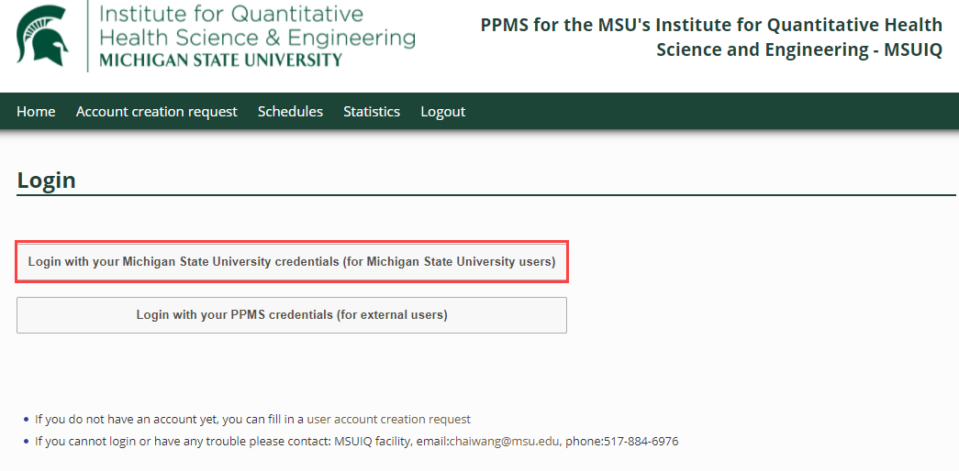
External users: Click Account creation request at the top of the page.
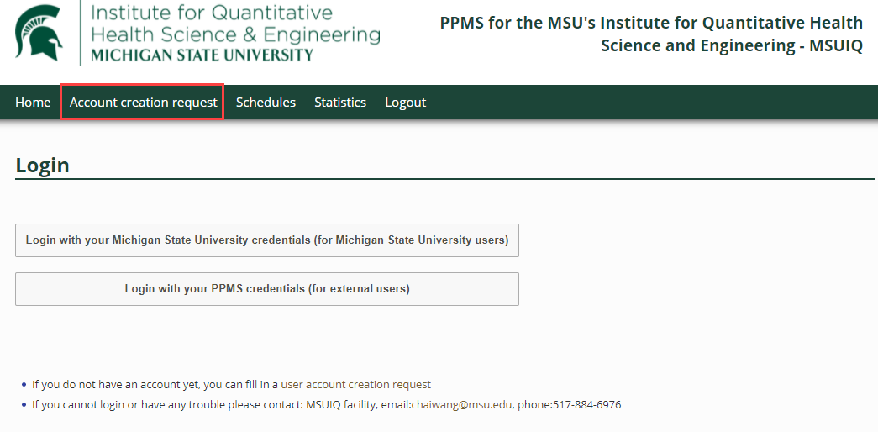
Step 4: Complete your user profile and the required account information and click Submit form. A valid account number is required for all internal users.
Internal MSU | External User
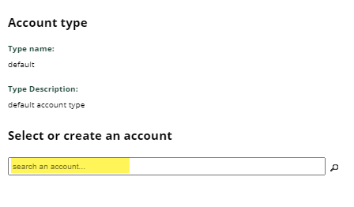 | 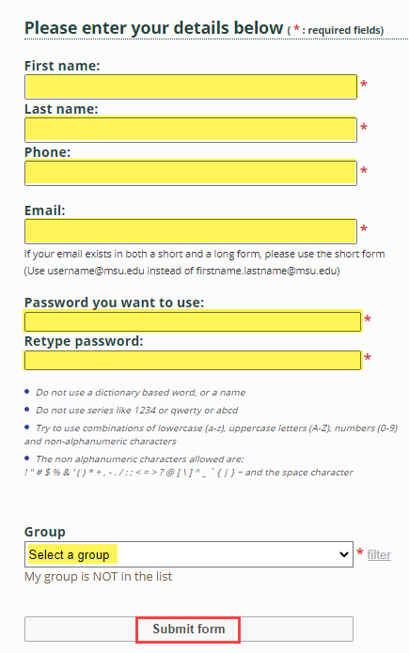

Logging into PPMS
To log in to the system, please follow these steps:
Step 1: Navigate to https://ppms.us/msu-iq and login with your MSU credentials (MSU NetID). If you are an external user, enter your PPMS username and password.
Step 2: Login with your MSU credentials or, if you are an external affiliate, enter your PPMS username and password.
Internal | External User
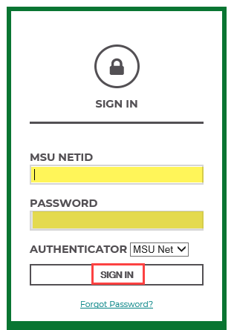 | 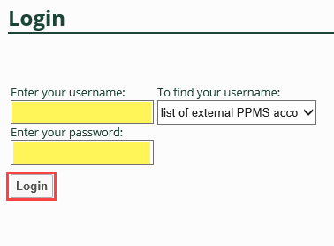

Book a System
To book a system, please follow these steps:
Step 1: From the Home page, open the Systems available dropdown and select the system.
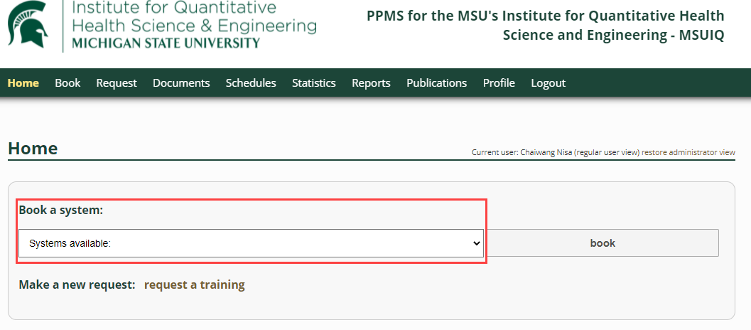
Note: If the system you are looking for is not listed, it may be that you do not have permission to book. Click “Request a training” or contact the Core Manager directly.
Step 2: You will be directed to the scheduling page. Verify the account number is correct. Click the checkbox(es) for the desired time slots and click Book the selected sessions at the bottom of the calendar.

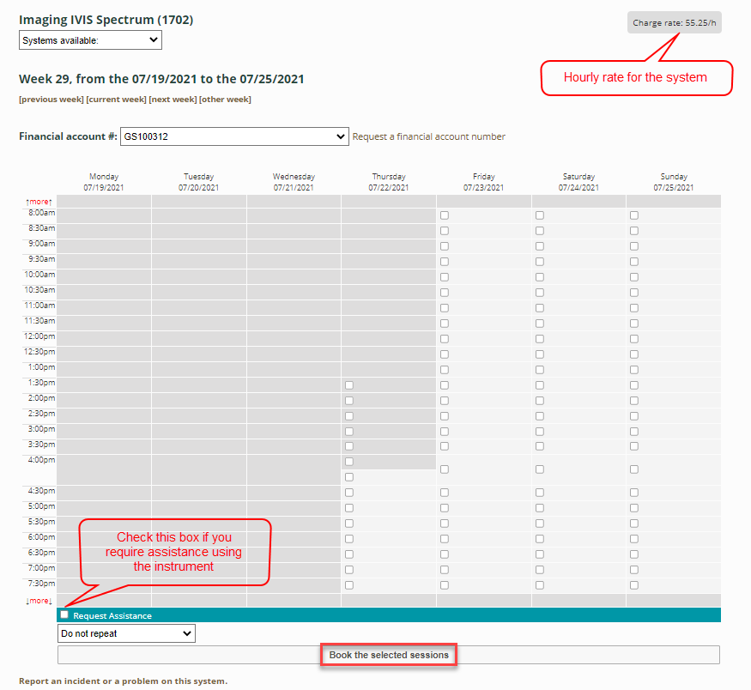

Request Training
If you would like to request training for a system, please follow these steps:
Step 1: From the Home page, click request a training. Verify you are submitting this request to the correct instrument/facility.
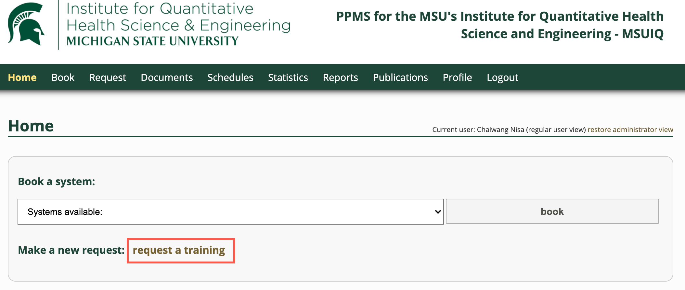
Step 2: Complete the form and click Submit request.
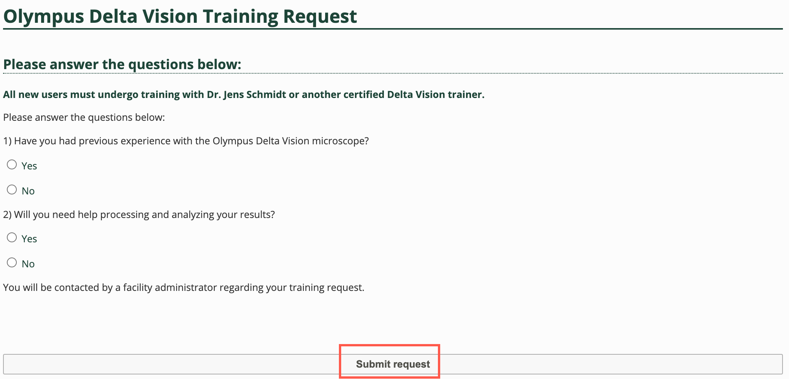
You will be contacted by the Core staff to coordinate the training.

