The Advanced Molecular Imaging (AMIF)
Erik Shapiro, PhD: Faculty Director

Christiane Mallett, PhD: Christiane has over 10 years of experience with preclinical imaging. Her work has focused on developing and applying MRI and PET/MRI techniques for measuring disease progression and treatment in rodent models of disease. She has extensive experience in experimental design, image acquisition and training users on all imaging systems.

Jeremy Hix, BS LATG SRT: Jeremy has over 10 years of experience in preclinical research using telemetry and imaging, and is a Laboratory Animal Technologist (LATG) certified by the American Association for Laboratory Animal Science (AALAS). Jeremy is also an accomplished Surgical Research Technician (SRT) certified by the Academy of Surgical Research (ASR) and has extensive surgical experience, with a particular focus on vascular surgeries.

Facility Description:
The Advanced Molecular Imaging Facility (AMIF) is a service center to support the small animal imaging needs of MSU researchers and off-campus academic and commercial institutions. It is located in 2000 sq. ft. on the first floor of the Institute for Quantitative Health Science and Engineering (IQ) on the south end of Michigan State University’s campus.
Facility staff provide assistance with experiment design, train users to acquire images on all systems or acquire images for users on a fee for service basis. We have several computers for image analysis running a variety of image analysis software and can train users on analysis or perform analysis for a fee. All systems are equipped with isoflurane vaporizers and nosecones for imaging-related surgical procedures. The room has a downdraft table for necropsies or other procedures involving formalin.

Imaging Instruments:
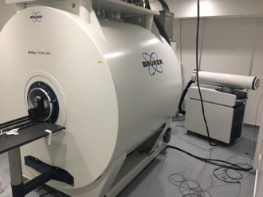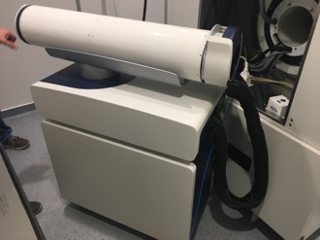
PET
MRI courtesy
The PET insert can be used as a stand-alone imaging unit (Left) or can be inserted in to the MRI scanner to function as a PET/MRI system (right).
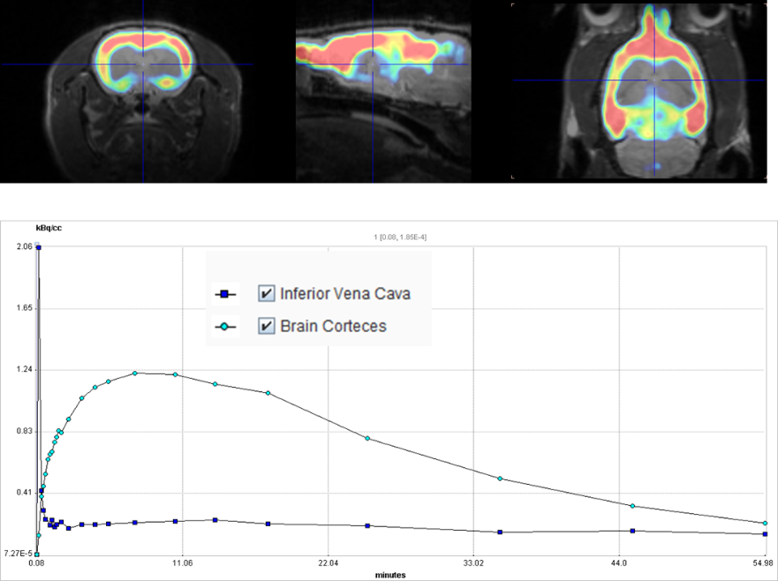
PET/MRI – Bruker BioSpec 70/30 with PET insert: This is a 7T MRI with an insert for simultaneous acquisition of PET images and is one of a handful of such systems installed around the world. We have specialized RF coils for proton imaging of mouse brain and body, rat brain and body, and larger animals up to rabbit size. The system has built-in sequences for high resolution anatomical imaging, functional MRI, diffusion weighted imaging, CEST, spectroscopy and many other applications. In addition to the full capabilities of preclinical MRI, we can perform simultaneous PET imaging with 5 second temporal resolution or 0.7 mm spatial resolution (FDG).
Dynamic PET/MR of ¹¹C-Flumazenil in rat brain. The accurate quantification and high acquisition rate capabilities of the PET system allows for the injection of minimal quantities of relatively shorted lived isotopes. The large FOV allows for whole body tracer kinetics analysis even in rats. The chart shows the spike in the inferior vena cava after a bolus injection which can be used to calculate the input function (blue squares). The dynamic uptake and clearance in the brain cortices is also shown (green circles). (Data courtesy Bruker Biospin)
FDG for PET imaging is acquired from Cardinal Health, which is next door. There is also a radiopharmacy for development of new probes in both non-cGMP and cGMP environments. Other isotopes (eg. Cu-64, Y-86, Zr-89) can be received from facilities around the country as required. The room is fully equipped for administering PET agents, with appropriate lead shielding, a dose calibrator and survey meters.
In addition, the AMIF has access to a second 7.0T (31 cm bore) Bruker Biospec system and a 9.4T Bruker system (9 cm vertical bore), which are located in the center of campus, in the Biomedical and Physical Sciences building. These systems are capable of high resolution anatomical MRI, functional MRI, and multi-nuclear MRS, including ¹⁹F and ³¹P. All of the animal systems are equipped with state-of-the-art electronics and pulse sequence capabilities. Custom-built and commercial RF coils for a wide range of applications and nuclei are available for all MRI systems.
Analysis workstations are equipped with Paravision360 and PMOD with the fusion and kinetic modeling packages. Other analysis packages for PMOD may be purchased if required, such as ones for cardiology and neurology applications.

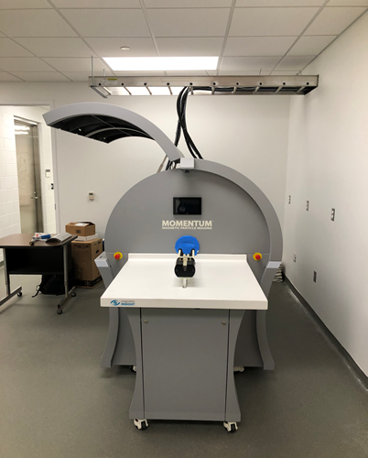
MPI – Magnetic Insight MOMENTUM scanner: The magnetic particle imager is the first of its kind installed in the US and the third of the installed base world-wide (Image to the Right). This imaging system from Magnetic Insight detects superparamagnetic iron oxide particles based on their magnetic properties and creates a bright image on a dark background. It includes a relaxometry module for particle characterization. The mouse bed has fiducial markers for simple co-registration of 3D images with µCT. An analysis workstation has VivoQuant for MPI image analysis.

Hyperthermia – Magnetic Insight HYPER: This system causes hyperthermia through magnetically-induced heating of iron oxide nanoparticles. The Momentum magnetic particle imaging system can be used to identify target locations, and then the animal can be moved to the HYPER for seamless treatment. Temperature is monitored in real time through a fiber optic system and two digital cameras are used for positioning. Heating data is exported as a .csv file for offline analysis and reporting.

Fluorescence and Bioluminescence – Perkin Elmer IVIS Spectrum: This versatile, advanced in vivo bioluminescent and fluorescent pre-clinical imaging system that combines high-throughput and full tomographic optical imaging in one platform. The light tight imaging chamber with heated stage and integrated gas anesthesia (isoflurane) allows for non-invasive longitudinal monitoring of disease progression, cell trafficking and gene expression patterns in living animals. An optimized set of high efficiency filters (10 narrow band (30nm) excitation and 18 narrow band (20nm) emission filters) and advanced spectral unmixing algorithms allow spectral scanning over blue to near infrared wavelengths with visualization of multiple reporters (bioluminescent and/or fluorescent) in the same animal. 3D diffuse tomography for both bioluminescent and fluorescent optical signals can be quantified to determine source location and concentration, and analyzed to provide anatomical context following co-registration with the digital mouse atlas (or other imaging modalities eg. µCT, or MRI). Mouse phantoms (bioluminescent and fluorescent) are provided. Images are analyzed using LivingImage.

µCT – Perkin Elmer Quantum GX: The Quantum GX CT imaging system offers a resolution that is suitable for all analytical CT applications and includes cardiac and/or respiratory gated imaging, a bore size that enables imaging of a wide range of species, and an adjustable energy range of 20-90 kV. The Quantum GX offers the highest resolution among all the microCT scanners for in vivo imaging. The large field of view (FOV) of 72x72 mm allows for high resolution imaging of mice, rats and rabbits. The system has three modes: high resolution, high speed and standard modes. As an example, in the high-resolution mode, a 4.5 μm voxel size resolution can be attained at a 36 x 36 mm FOV, while a 9 μm voxel size resolution can be attained at 72 x 72 mm FOV.
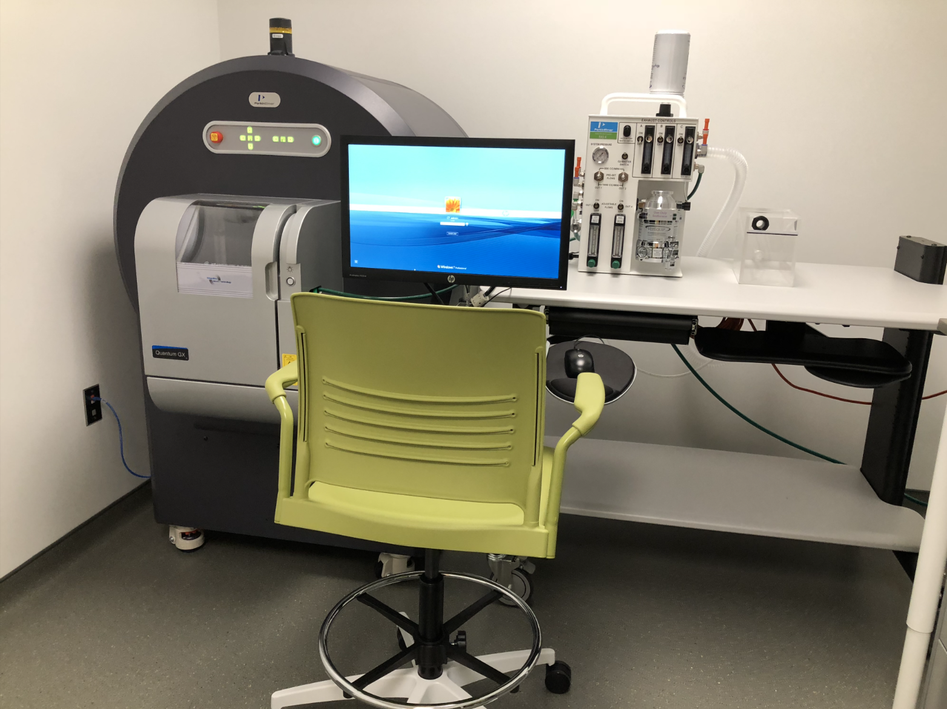
CT Scaner in IQ
The Quantum GX is the fastest microCT system with industry leading scan times of 8 seconds in the high-speed mode. With a reconstruction time of 15 seconds, a 3D image can be acquired and reconstructed with the GX in 23 seconds. Quantum GX’s sub-reconstruction features allow users to reconstruct an acquired image at higher resolution without the need to rescan the subject thus reducing both the time needed for a study and the amount of radiation exposure to the animal. Consequently users can take multiple scans with minimal radiation impact and adverse physiological outcomes. The Quantum GX has the lowest radiation dose exposure of all µCT scanners on the market due to the use of a CMOS detector. The AMIF has 2 bone mineral density calibration phantoms for use on this system.
Images are analyzed using Analyze 14.0 and additional bone analysis modules are available for morphometric ASBMR analysis of cortical and trabecular components (AccuCT and BMA).

Optoacoustic Imaging – iThera MSOT inVision 512-echo
This is a hybrid optoacoustic/ultrasound imaging system for imaging mice and rats. Tissues undergo thermoelastic expansion after they are illuminated by a pulsed laser, which generates ultrasound waves that are detected by a 270° array of 512 5MHz ultrasound detectors. Co-registered tomographic ultrasound and photoacoustic images are produced at a 150 µm resolution. The subject is moved through the detector ring for full body coverage. Contrast can be endogenous (deoxyhemoglobin vs oxyhemoglobin) or from exogenous agents such as indocyanine green, methylene blue or nanoparticles. There is also a hand-held unit for imaging larger subjects. Images are analyzed using Invision software provided by iThera.

Animal Housing:
Mice and rats used for imaging studies are housed in holding rooms inside the imaging core, which are maintained by Campus Animal Resources. Facilites are accredited by AAALAC and registered with the USDA. Animals are housed in sterile cages, and the rooms are equipped with bio-safety cabinets and a lead cave for holding radioactive animals. In general, animals may not return to other housing after being used in imaging studies, although in exceptional cases this may be arranged through Campus Animal Resources.

